J3 Mart 01/03/2025

Justine Denise B. Hernandez

1. What have I done so far?

Created the UI and Functionality for the Create Announcement Screen:

* Recipient text and text field
* CC text and text field
* Subject text and text field
* Tags text and dropdown for selection
* Body text field
* Exit button
* Save as draft and send buttons
* Scheduled send button (show date and time dropdown after pressing this button)
* Scheduled send, save as draft, and send functionality.
* Can select multiple tags

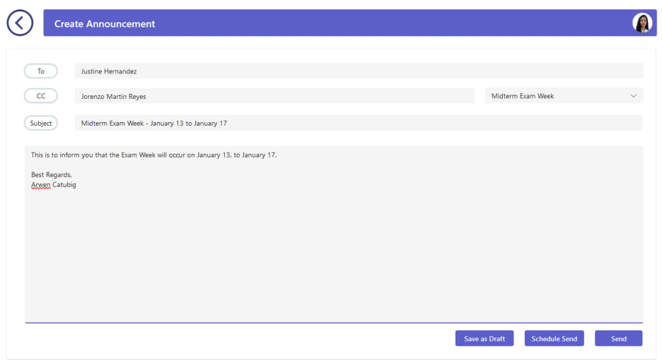

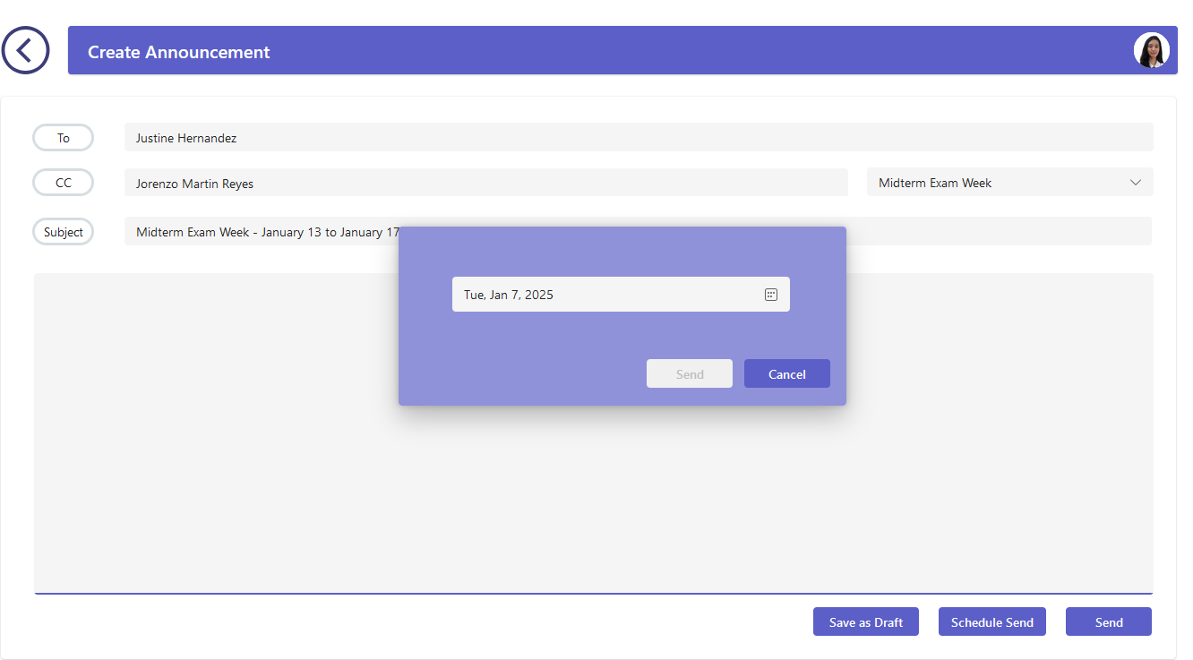

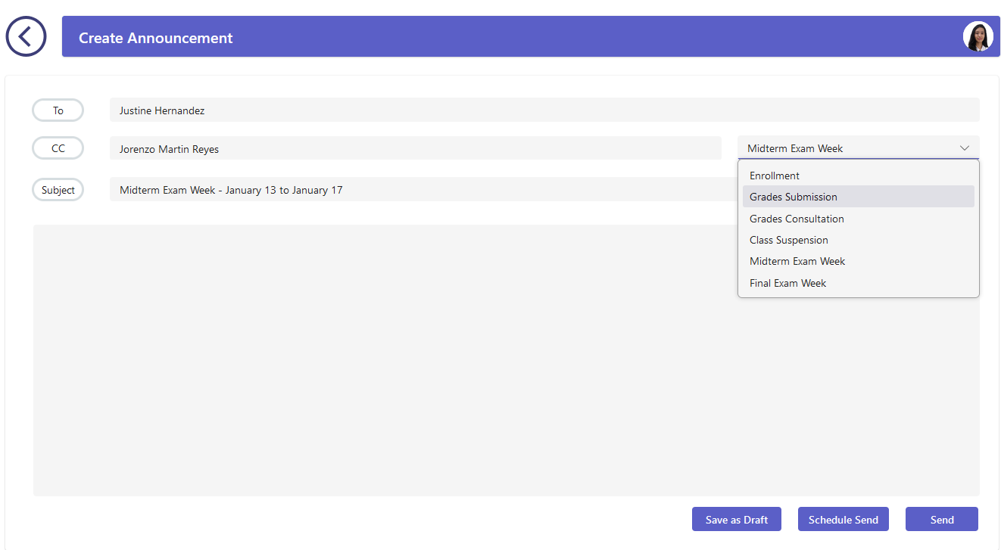

1. What will I do next?
   1. Save as Draft Container
   2. Add resend button
2. Possible Challenges?
   1. The input for time is currently not included